1. 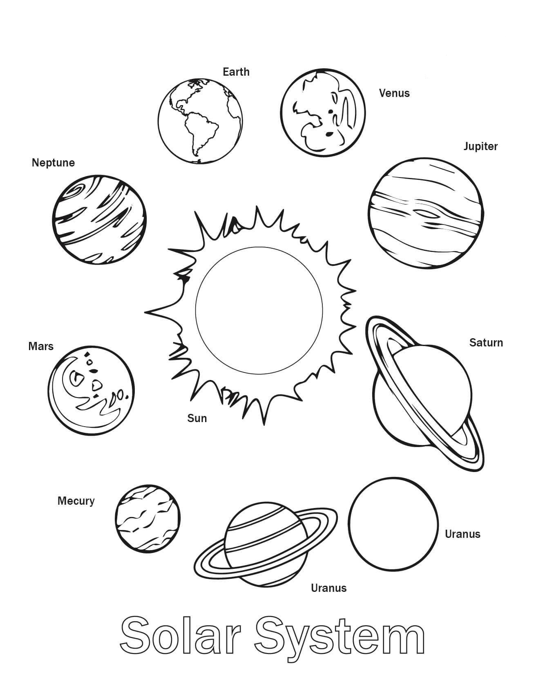Colour in the Sun and the planets of the Solar System
2. Cut out the Sun and planets
3. Onto an A3 page glue the Sun followed by the planets in the order they exist in the solar system
4. Research the following information on each planet and display it on the A3 graphic organiser
   1. Distance from the Sun, diameter of the planet, terrestrial planet/gas giant/ice giant, number of Earth days per orbit of the Sun, surface temperature, length of a day relative to Earth, fun facts
5. Research and add at least one addition feature of the solar system e.g. Halley’s comet, Pluto, asteroid belt, Kuiper belt, Oort cloud